J2ME Sample Game 17 – AutoResume MIDlet

- Screenshots

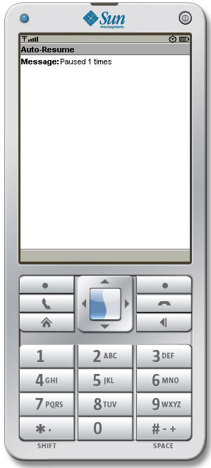

- Source Codes

- AutoResume.java

import javax.microedition.lcdui.*;
import javax.microedition.midlet.MIDlet;
import javax.microedition.midlet.MIDletStateChangeException;

public class AutoResume extends MIDlet
{
private Form mainForm;
private StringItem message;
private int nPause;
public boolean isPaused;

public AutoResume()
{
super();
mainForm = new Form("Auto-Resume");
message = new StringItem("Message:", "Message here");
mainForm.append(message);
nPause = 0;
isPaused = true;
}

protected void startApp() throws MIDletStateChangeException
{
isPaused = false;
System.out.println("startApp");
Display.getDisplay(this).setCurrent(mainForm);
message.setText("Paused " + nPause + " times");
}

protected void pauseApp()
{
nPause++;
isPaused = true;
System.out.println("pauseApp");
AutoResumeThread t = new AutoResumeThread(this);
t.start();
}

protected void destroyApp(boolean arg0) throws MIDletStateChangeException
{
System.out.println("destroyApp");
}
}

- AutoResumeThread.java

public class AutoResumeThread extends Thread
{
private AutoResume m_mainThread;
public AutoResumeThread(AutoResume mainThread)
{
m_mainThread = mainThread;
}

public void run()
{
int nSleep = 0;
while (m_mainThread.isPaused)
{
try
{
System.out.println("Sleeping");
sleep(1000);
}
catch (InterruptedException e)
{
System.out.println(e.toString());
}
nSleep++;
if (nSleep == 5)
{
System.out.println("Requesting resume");
nSleep = 0;
m_mainThread.resumeRequest();
}
}
}
}

